MS.NET
Mini Project
Order and Invoice Management System
(OIMS)

Document Revision History

Date | Revision No. | Author | Summary of Changes
27th Feb 2017 | 1 | Vijay Vishwakarma | Initial Draft

Table of Contents
Introduction 4
Setup Checklist 4
Instructions 4
Problem Statement 5
Objective 5
Abstract of the project 5
Functional components of the project 6
Technology used: 7
Implementation 8
Summary of the functionality to be built: 8
Guidelines on the functionality to be built: 9
Evaluation and assessment parameters 13

Introduction
This document outlines a mini project for the .NET Line of Technology (LOT). The project is to develop an Order and Invoice Management System (OMTBS). This document contains the work flow of the system and gives guidelines on how to build the functionality gradually in each of the course modules of the .NET LOT.

Setup Checklist
Minimum System Requirements
- Intel Pentium 4 and above Windows XP, 2000 and 2003
- Memory 1 GB
- Internet Explorer 6.0 or higher
- SQL Server 2012 client and access to SQL Server 2012 server
- Visual Studio 2013

Instructions
- The code modules in the mini project should follow all the coding standards.
- Create a directory by your name in drive <drive>. In this directory, create a subdirectory MiniProject. Store your Project here.
- You can refer to your course material.
- You may also look up the help provided in the MSDN
- Since this project work will span over couple of months, you will need to take care of maintaining the code

Problem Statement

Objective
Development of an Order and Invoice Management System (OIMS)

Abstract of the project
This project is aimed at developing an Order and Invoice Management System (OIMS).

Acme inc is organization which manufactures stationary items like books, pen , printing paper etc. They receive order from all over the country for their stationary product. Initially they are managing all the activities like inventory management and order management manually. They want an online application which will allow the internal employee of the organization to maintain product and customer record as well as maintain the details of the order place and creating invoices for the same.

The System will have Two Users: - Admin and Clerk

Role of Admin:-
- Managing Category Information
- Managing Product Information
- Managing Customer Information
- Managing User Details
- Generation of reports like Sales based on category and Product

Role of Clerk:-
- Creating new order
- Generating Invoices
- Printing of Invoices

Functional components of the project
Application Architecture:
Distributed web applications traditionally to be designed and built across three logical tiers:
- Database Access Layer (DAL)
- Business Logic Layer (BLL)
- Presentation Layer

The DAL refers to the database itself, the stored procedures, and the component that provides an interface to the database. The BLL refers to the component that encapsulates all the business logic of the application. And, the Presentation layer refers to the web application pages.

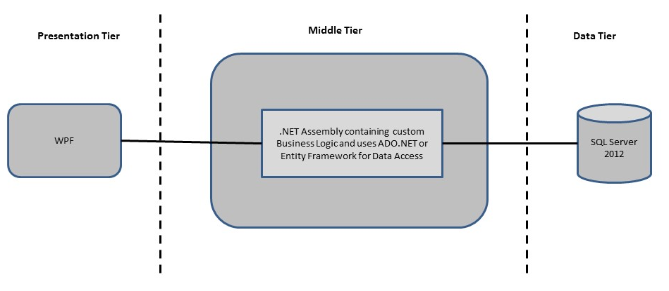

Design guidelines
- All the exceptions/errors to be captured and user friendly message to be displayed on the Common Error page (to be done during PLP).
- Data access layer Data access layer Use ADO.NET. Make use of stored procedures. All the database interaction would be performed using Data Access Component. Most common methods in Data Access Component would be –
- Create Connection to the Database
- Create Command Object
- Set Command Type to Stored Procedure
- Create and Populate Parameters
- Execute the Command
- Close the Connection

Technology used:
    - Presentation Layer
        - WPF 4.5

    - Business Layer
      - Business Logic Components and Services :-
        - C# 5.0
    - Database Layer
      - Databases:-
        - SQL Server 2012

Sr. No | Course | Duration | Functionality to be built
Sr. No | Course | (in PDs) | Functionality to be built
1 | MS SQL Server 2012 | 4 | Creating relevant database tables and stored procedures
2 | NET Framework 4.5 + C# 5.0 | 7.5 | Developing Business components (C# classes)
3 | ADO.NET 4.5 | 3 | Integrating the DAL ,BLL and PL
4 | LINQ and Entity Framework | 2 | Creating data model and data context and using LINQ to Entities
5 | WPF 4.5 | 2 | Incorporating advanced UI functionality with WPF 4.5
6 | Mini Project Presentation | 1 | The Mini Project Presentation day

Note: Saturday half day will be devoted for mini project

Implementation

Summary of the functionality to be built:
The participants need to develop the Order and Invoice Management System by building the functionality incrementally in each of the course modules of .NET LOT.

Guidelines on the functionality to be built:

The functionality and components to be built in each of the course modules of .NET LOT is as follows:

1) Course: SQL Server 2012

This section describes some of the basic steps involved in designing and creation of the database for the application.

Create Data Model - identify the different tables and fields that we will need, which would later be used for building the rest of the application.

Database Schema - Create the following database tables (make your assumptions incase you require few more fields)

- Category :- CategoryID, CategoryName , Description
- Product:- ProductID, ProductName, UnitType, Price, CategoryID, Description
- Customer :- CustomerID, CustomerName, Contact, Email, Address, City, Pincode
- Order :- OrderId, OrderDate, CustomerID, Amount
- OrderDetails:- OrderID,ProductID,UnitPrice, Quantity
- Invoice:- InvoiceID, OrderID, InvoiceDate
- Users:- ID, Username, Password, Status

2. Course: Winforms 4.5, WPF 4.5

a. Develop the prototypes for following functionalities:
i. Login Page : This page will allow user to provide their login credential for authentication
ii. Home Page : This page will provides details based on user
iii. Maintain Customer page : This page will help admin to maintain customer details
iv. Maintain Product page : This page will help admin to maintain product details
v. Maintain Category page : This page will help admin to maintain category details
vi. Maintain User Page : This page will help admin to maintain users details
vii. Orders Page : This page will help clerk to create new orders
viii. Invoice Page : This page will help clerk to generate and print invoice

b. In this course you need to develop the user interface using Winforms and WPF. The screens should include the fields as per the functionality mentioned above. Include Validations where ever required.

3. Course: C# 5.0 and ADO.NET 4.5

- Develop business components (C# classes) for the above functionality:

- Category Class:- This class will contain methods for managing Category Information
- Product Class:- This class will contain methods for managing Product Information
- Customer Class:- This class will contain methods for managing Customer Information
- Users Class:- This class will contain methods for managing Users Information
- Order Class:- This class will contain method for managing Orders Information
- OrderDetails Class:- This class will contains method for managing Orderdetails information
- Invoice Class:- This class will contains method for managing Invoice Information

You need to create Layered Architecture which comprises of Presentation Layer (WPF),Business Logic Layer (C# Classes) and DAL Layer(Using ADO.Net 4.5 or LINQ and Entity Framework)

DAL Layer of ADO.NET 4.5 will include all the required code snippets for CRUD Operations.

All the CRUD operations should use SQL Server Stored Procedures (For Insert, Update, Delete & Search).

The connectionString should be stored in the configuration file only.

OR

4. Course: LINQ and EF
a) using the Database first approach of Entity framework create a entity data model form the database created in earlier steps. The Entity data model should consist of the following entities

- Category Class:- This class/entity will hold Category Information
- Product Class:- This class/entity will hold Product Information
- Customer Class:- This class/entity will hold Customer Information
- Orders Class:- This class/entity will hold Orders Information
- Order Details Class:- This class/entity will hold Orderdetails Information
- Invoice Class:- This class/entity will hold Invoice information
- Users Class:- This class/entity will hold Users Information

b) Using DataContext to perform CRUD operations and use LINQ to implement the required business logic in the application (like retrieving data, sorting data, searching data etc).

5. Course: ADO.NET 4.5 and WPF 4.5
  - Integrate all screens (WPF ) with business components (C# classes) to complete the entire functionality.

Project Evaluation Guidelines
The project it is to be evaluated based on the following five parameters:

- Proper Database Structure and UI designing as per the specifications –(15 Marks)
  - Proper Database Design and Stored Procedure
  - Visual look and feel of the UI
- Project Completion – (20 Marks)
  - Timely Completion of the project
  - Integration of all component of the system
- Defect free execution – (30 Marks)
  - Error free execution of individual modules and the whole system
  - Validation
  - Functionality as per the specified requirements
- Compliance of standard and guidelines – (15 Marks)
  - Appropriate comments entries
  - Adherence to naming conventions for classes, functions, variables and files
  - Simplicity of user interface and screen layouts
  - Maintainability of codes (for example, no one function should be more than 100 lines)
- Group Presentation and Query handling – (20 Marks)
  - Participants (Group of 3 to 4) to present the project with UML Diagrams(use case diagram and one of the sequence or activity diagram) and PPT

